Appendix 1: Assignment submission cover sheet
ASSIGNMENT SUBMISSION COVER SHEET

Cse25-222
Student Id:

Suping Kagiso
Student names:
Cse25-222@thuto.bac.ac.bw
Student email:
2026
Cohort:
SCIS WMD_2026 A01

Assignment title:

20/03/2026
Date of submission:
BSC COMPUTER SYSTEMS ENGINEERING
Programme of Study:
YEAR 1
Year of Study:

Intellectual property statement
By checking the box below, I certify that this assignment is my own work and is free from plagiarism. I understand that the assignment may be checked for plagiarism by electronic or other means and may be transferred and stored in a database for the purposes of data-matching to help detect plagiarism. The assignment has not previously been submitted for assessment in any other unit or to any other institution. I
have read and understood the Botswana Accountancy College plagiarism guidelines policy.
yes
Agree Signature…………k.suping………………………….
Date………20/03/2026………………………………….

PART A: SITE PLANNING AND SPECIFICATION
Question 1 (a): Purpose of the Website

The proposed website, CramLink-Imports, is planned as a web-based intermediary e-commerce platform that will enable users in Botswana to access and import products from international online marketplaces. The primary purpose of the system is to simplify the process of acquiring goods from global platforms such as Amazon, Alibaba, and AliExpress. These platforms often present challenges to local users due to payment restrictions, delivery limitations, and logistical complexities.

The system will therefore act as a bridge between global suppliers and local customers, allowing users to browse products externally, copy product links, and submit them through a structured order form. The business will then handle purchasing, shipping, and delivery processes. The overall goal is to create a centralized, user-friendly platform that improves accessibility, reduces complexity, and enhances the efficiency of international shopping for local users.

Question 1 (b): Target Audience

The target audience for the proposed system consists of individuals and small-scale entrepreneurs within Botswana who seek access to international products. This includes users who may not have access to international payment systems or who lack experience in online shopping. The platform will particularly benefit individuals who want to purchase items such as clothing, electronics, and accessories that are not readily available in local markets.

Additionally, the system will target small business owners and resellers who import goods in bulk for resale purposes. These users frequently rely on global supplier platforms such as Alibaba to source affordable products. The system is designed to accommodate users with varying levels of technical knowledge by providing a simple and guided interface.

From an audience analysis perspective, the typical users are expected to:
1.Have basic smartphone or computer literacy
2.Use mobile internet connections
3.Prefer simple navigation and clear instructions
4.Seek convenience and reliability in online services

Question 1 (c): Key Features of the Website

The proposed CramLink-Imports system can be classified as an e-commerce service website, as it facilitates commercial transactions by enabling users to request and import products from international markets. Unlike traditional online stores, the system operates as an intermediary service that manages the purchasing and delivery process on behalf of users. In addition to being an e-commerce platform, the system also functions as a portal website, as it provides users with access to external marketplaces such as Amazon and Alibaba, allowing them to browse products before submitting their orders. Furthermore, the system has functionality of a web application due to its interactive features, including user authentication, order submission, and order tracking functionalities. These combined characteristics demonstrate that the system is not a simple informational website but a dynamic and service-oriented platform.

Question 2: Information design & Taxonomy
The proposed system will include several core features designed to ensure usability, efficiency, and functionality. Firstly, the system will provide user authentication, allowing users to register and log into their accounts securely. Once logged in, users will access a customer dashboard, which will serve as the central control panel for navigating the platform.

A key feature of the system is the order submission functionality, which will allow users to enter their email address, paste product links from external marketplaces, describe the product, specify quantity, and provide payment details. The system will include validation mechanisms to ensure that inputs such as email addresses and URLs are correctly formatted.
Another important feature is the order tracking system, which will allow users to monitor the progress of their orders through predefined stages such as:

Order Submitted

Processing

Shipped

Delivered
In addition, the website will include direct links to international marketplaces such as eBay and Shein to assist users in browsing products before submitting orders.

These features are designed to create a complete user journey, from product discovery to order tracking, within a structured and easy-to-use environment.

Site Map (Website Structure)

The site map represents the hierarchical structure of the website and how pages are interconnected.

Home (index.html)
│
|── Login (login.html)
│ └── Dashboard (dashboard.html)
│ ├── Submit Order (order.html)
│ │ └── Order Status (status.html)
│ └── Track Order (status.html)
│
└── Register (register.html)
└── Login (login.html)
Question 3: Page Template Design
This structure follows a hierarchical navigation model, ensuring that users can move logically from one section to another.
Page Layout Sketches (Wireframes)

Home Page Layout

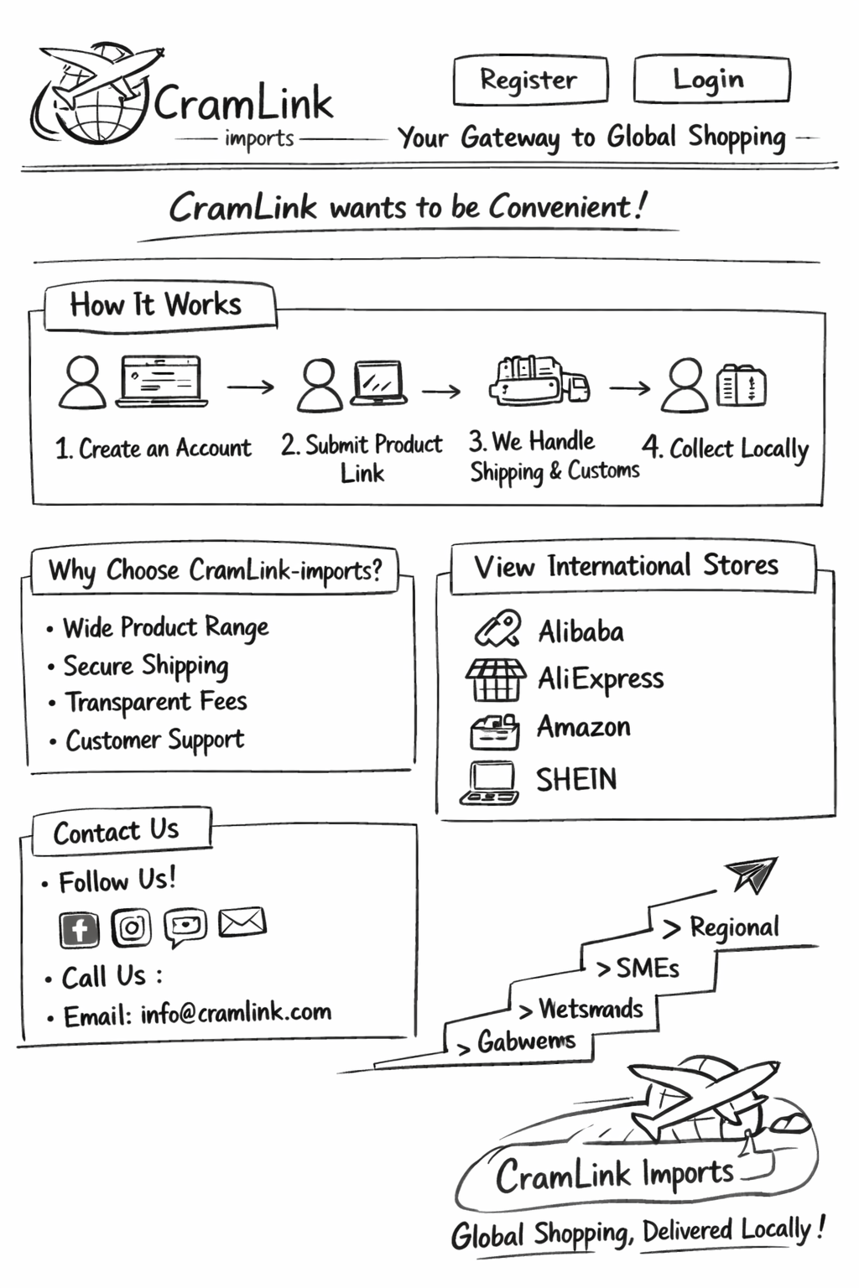

-------------------------------------------------
| LOGO | Login | Register |
-------------------------------------------------
| HERO SECTION |
| "Import Products From Global Markets" |
| [Submit Order Button]
|
-------------------------------------------------
| How It Works |
| 1. Browse Products |
| 2. Paste Link |
| 3. We Deliver |
-------------------------------------------------
| Marketplace Links |
-------------------------------------------------
| Footer (Contact Info) |

Dashboard Layout

-------------------------------------------------
| Dashboard | Logout |
-------------------------------------------------
| Welcome User |
-------------------------------------------------
| [Submit Order] [Track Order] |
-------------------------------------------------
| My Orders Table |
| Order ID | Product | Status
Order Form Layout

-------------------------------------------------
| Order Form |
-------------------------------------------------
| Email |
| Product Link |
| Description |
| Quantity |
| Payment Details |
| [Submit Button] |
-------------------------------------------------

These sketches represent the planned interface design before development, as required in site planning.

3. Navigation Flow (Storyboard)

The navigation flow illustrates how users will interact with the system.

User visits Home Page
↓
Registers Account
↓
Logs into System
↓
Accesses Dashboard
↓
Clicks "Submit Order"
↓
Fills Order Form
↓
Submits Order
↓
Redirected to Status Page
↓
Tracks Order Progress

This flow ensures a clear and logical user journey, improving usability and system efficiency.

Question 4: Technical Brief

The technical brief for the proposed CramLink Imports website outlines the technologies, tools, and technical requirements necessary for the development and operation of the system. The website will be developed as a web-based application using standard frontend technologies, including HTML for structuring content, CSS for styling and layout, and JavaScript for implementing interactivity and input validation. These technologies are selected due to their compatibility across different browsers and devices, ensuring accessibility for users with varying technical capabilities.

The system will be designed to operate on internet-enabled devices such as smartphones, tablets, and personal computers, taking into consideration that many users may rely on mobile internet connections. The website will follow a hierarchical directory structure to organize files efficiently, with separate folders for HTML pages, stylesheets, scripts, and media content. Relative URLs will be used to link pages within the system to ensure portability when transferring files to a web server.

In terms of development tools, the system will be created using coding environments such as jGRASP , while version control and project management will be handled using GitHub and Visual Code as a coding space. For future expansion, the system may incorporate backend technologies such as Java and a database management system to enable data storage and processing. Additionally, the website will be designed with accessibility and performance considerations in mind, ensuring that it functions effectively across different devices, browsers, and connection speeds.

Question 5: Quality Assurance

Quality assurance for the proposed CramLink Imports website will involve systematic processes to ensure that the system functions correctly and meets user expectations. This will include both technical testing and user-centered evaluation, as outlined in Chapter 3. Functional testing will be conducted to verify that all components of the website operate as intended, including navigation links, form submissions, and page redirections. For example, the system will be tested to ensure that users can successfully move from the homepage to the login page, access the dashboard, submit orders, and view order status.

Validation testing will be implemented to ensure that input fields accept only correctly formatted data. This includes verifying that email addresses follow standard formats and that product links begin with “http” or “https.” Cross-platform testing will also be conducted to ensure that the website performs consistently across different web browsers, operating systems, and devices.

In addition to technical testing, usability testing will be carried out to evaluate the user experience. This will involve assessing whether users can easily navigate the website, understand its features, and complete tasks efficiently. Feedback will be collected from test users to identify areas for improvement. These quality assurance processes are essential to ensure that the system is reliable, user-friendly, and ready for deployment.

Question 6: Publishing and Promotion

The proposed CramLink Imports website will be published to the internet through a suitable web hosting service provider. This process will involve selecting a hosting platform that meets the technical requirements of the system, including sufficient storage, bandwidth, and support for web technologies. A domain name will be registered to provide a unique and accessible address for the website. Once the hosting environment is prepared, all website files, including HTML, CSS, and JavaScript, will be uploaded to the server using file transfer methods such as FTP.

After publishing, the website will be accessible to users via the internet. Promotion strategies will then be implemented to attract users and increase awareness of the platform. These strategies may include social media marketing, online advertisements, and word-of-mouth promotion within the local community. Additionally, the website may be promoted through partnerships with local businesses or resellers who can benefit from the import services offered. Effective publishing and promotion are essential to ensure that the website reaches its intended audience and achieves its objectives.

Question 7: Future Developments / Recommendations

The proposed CramLink Imports system has significant potential for future development and improvement. One of the key recommendations is the integration of a backend system using technologies such as Java and a database management system to enable permanent storage of user data and order information. This will allow the system to support real-time processing, improve efficiency, and enhance data management capabilities.

Another important development is the implementation of secure payment processing through trusted payment gateways, which will improve transaction security and user trust. The system can also be enhanced by introducing real-time order tracking, enabling users to receive accurate updates on the status of their shipments. Additionally, the development of an administrative interface will allow system administrators to manage orders, verify payments, and update order statuses efficiently.

Further improvements may include optimizing the website for mobile devices, enhancing user interface design, and incorporating notification systems such as email or SMS alerts. These future developments will transform the system from a basic into a fully functional and scalable e-commerce service platform capable of meeting the evolving needs of its users.

